1. 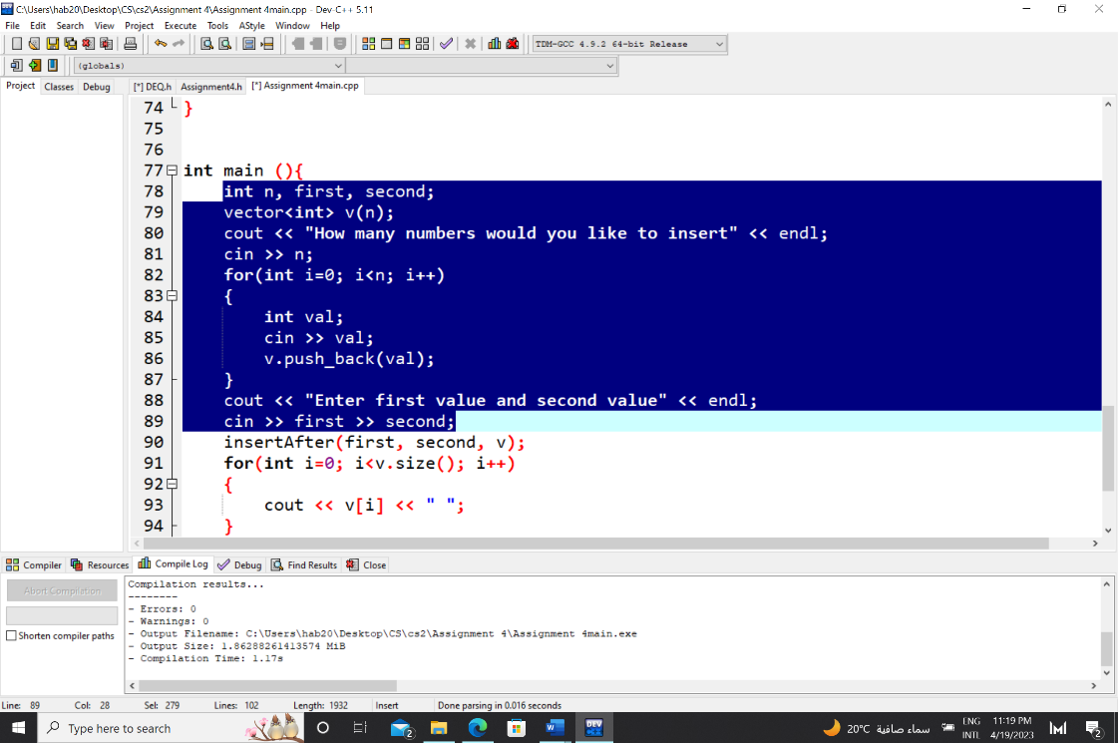

I first created a vector in the main function and used a for loop from 0 to the n value input by the user. The user is then asked to enter the first and second values for the insertAfter function.

1. 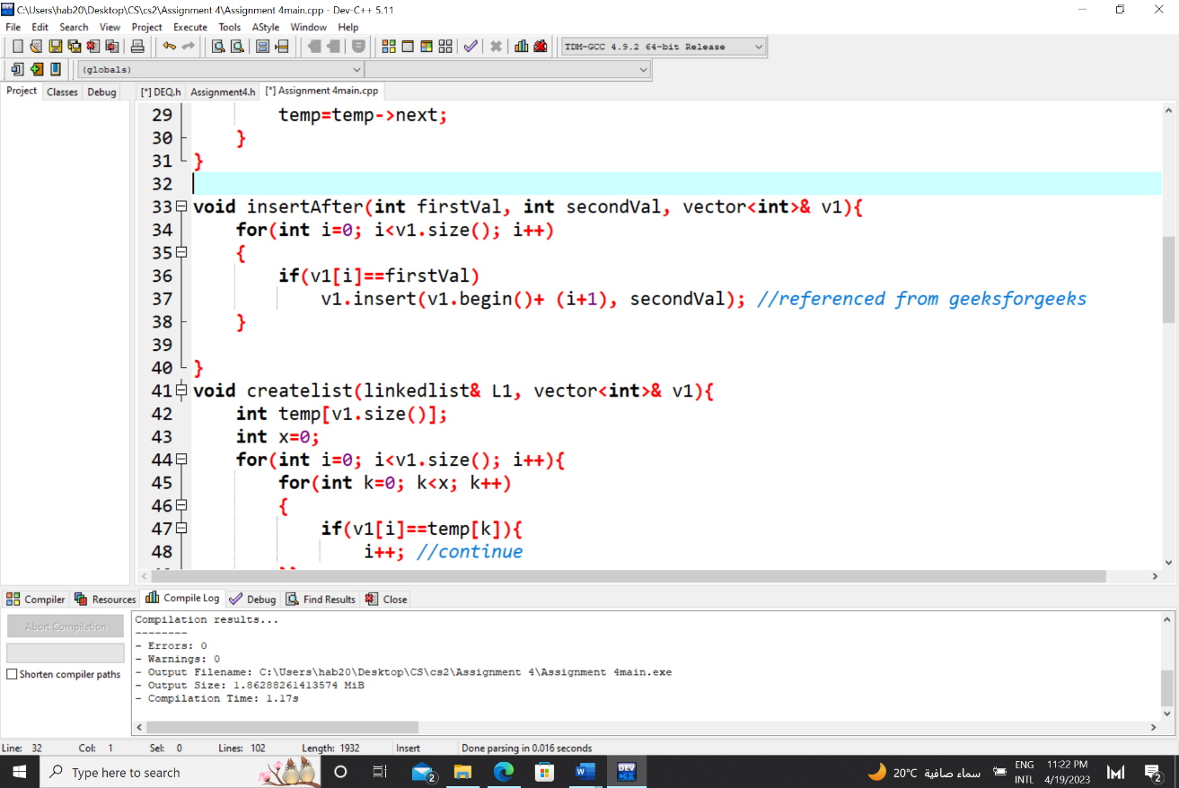

The insertAfter function is then called from the main, passing to it the first and second values and the vector by reference. The for loop from 0 to the size of the vector first checks if the value of the vector at the current index is equal to the first value passed. If so, the second value is inserted into the vector at the i+1 position.

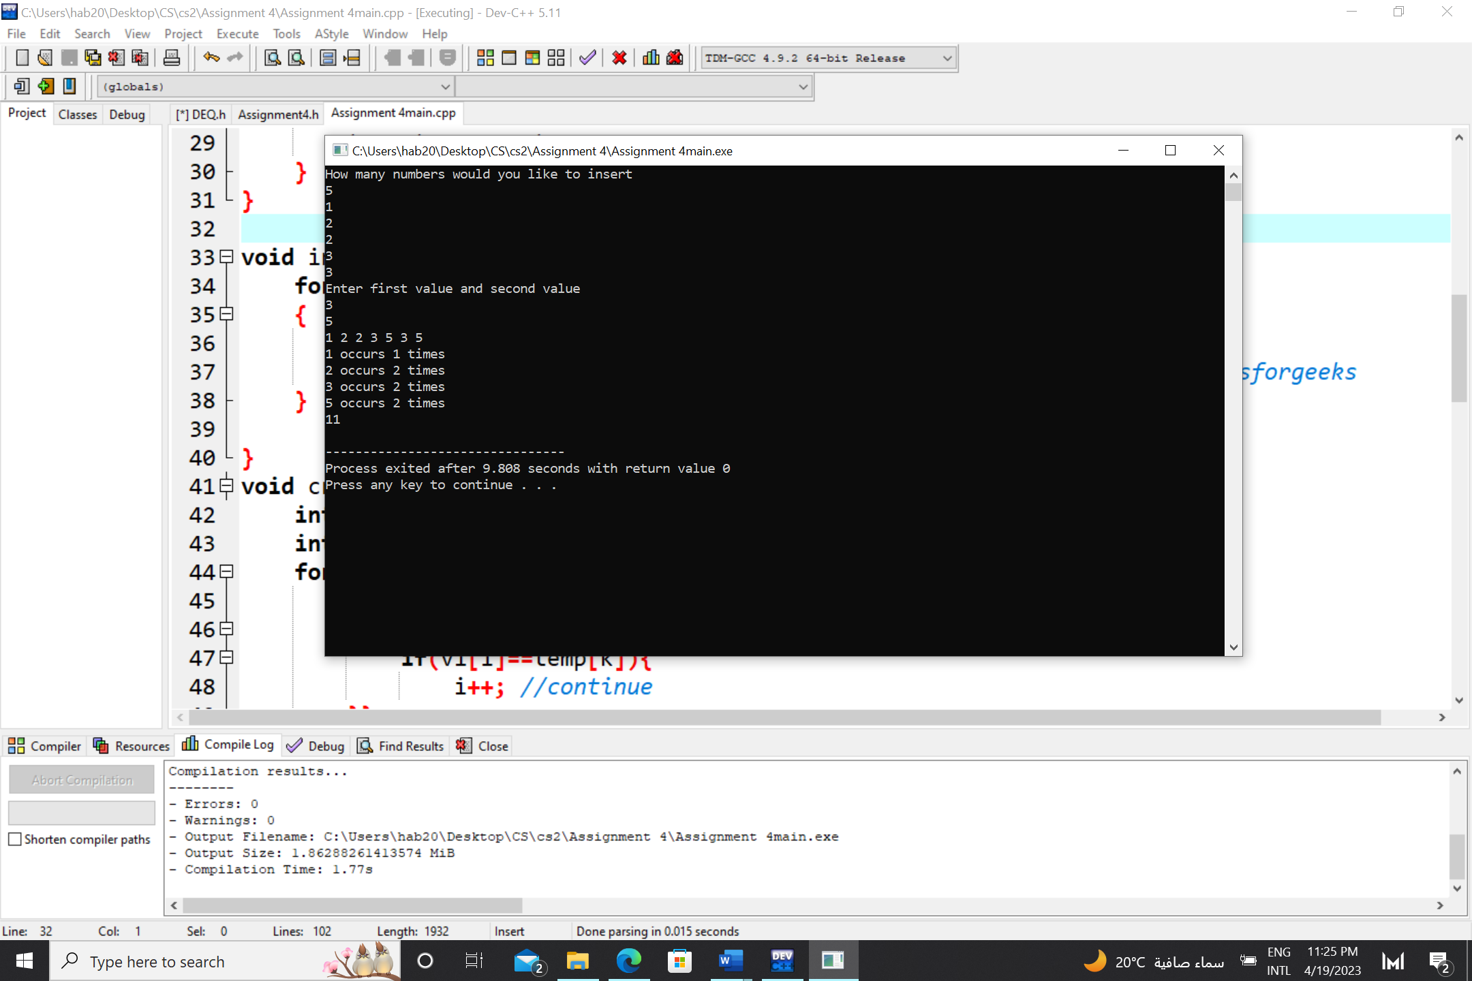Example:

Here, it is shown that it inserts 5 (second value) after every 3 (first value) in the vector.

1. 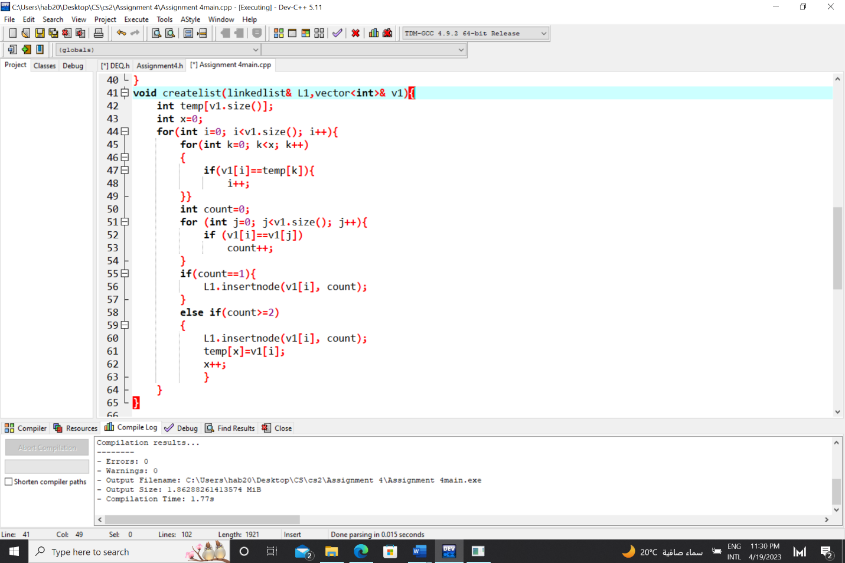

An object of the linkedlist class is created in the main and then a function, createlist, is called which takes an object of the linkedlist class and a vector by reference. The function traverses the vector and checks it against itself (v1[i] is compared to v1[j]) to check if any of the values are repeated. If the values are repeated the counter is incremented. Both ways, the insertnode function of the linkedlist class is called.

If the number occurred more than once in the vector, that number is stored inside a temp array and its index (x) is incremented.

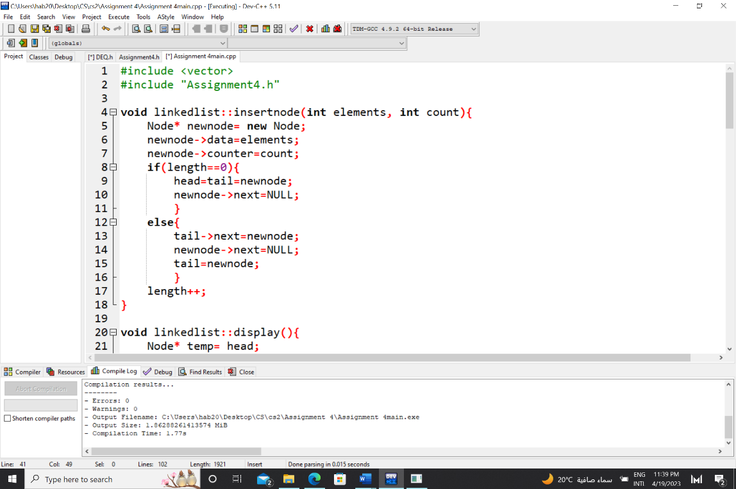When the “i” is incremented and the loop is entered again, it first checks the vector against the temp array. If any of the values of the vector are present inside the array, this means that that value was previously inserted into the linked list and thus “i” will be directly incremented without going through the whole loop.

This is the insert member function for reference.

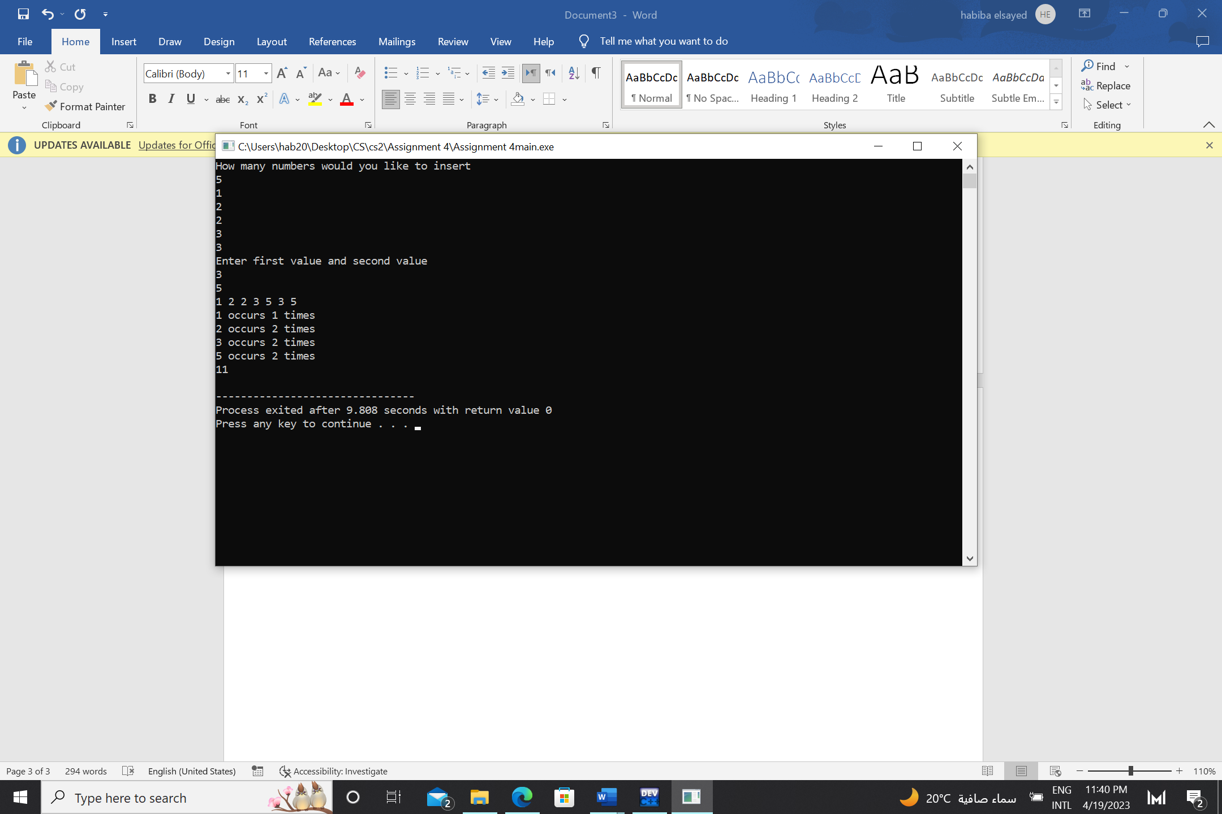Example:

The vertical line marked is the values of the nodes in the linked list in addition to the number of occurrences written next to them.

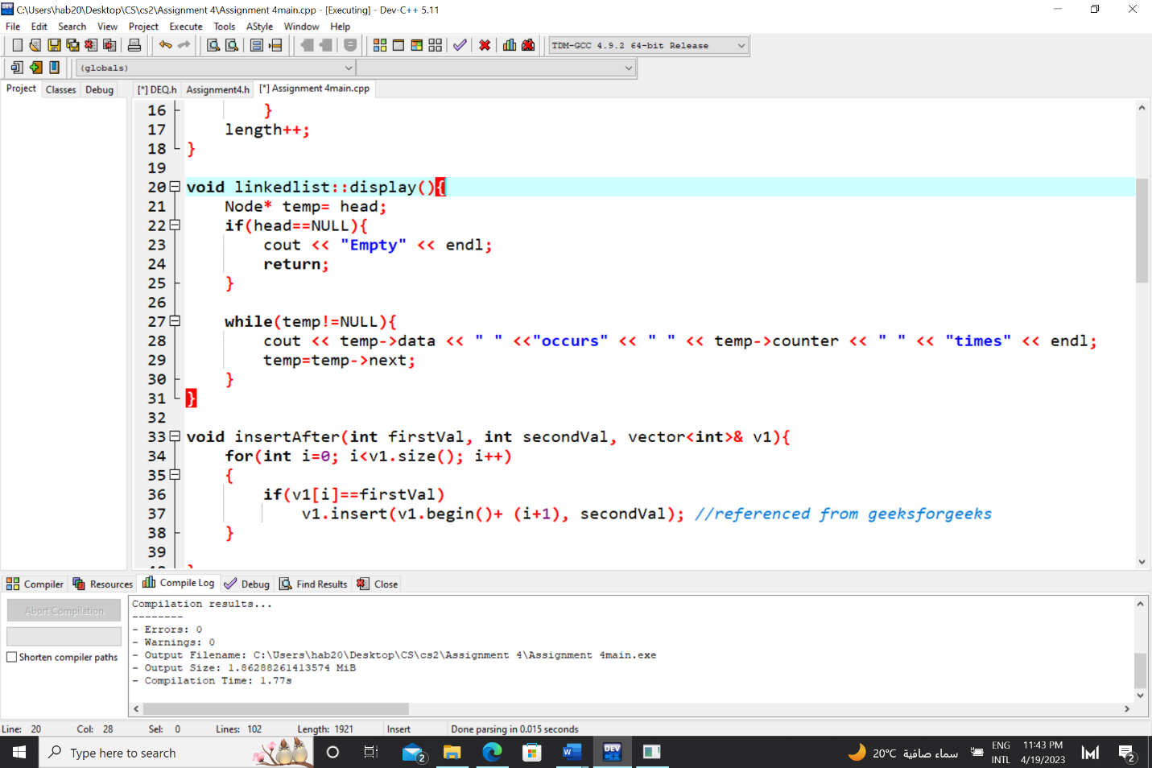

This is the display function for reference.

1. 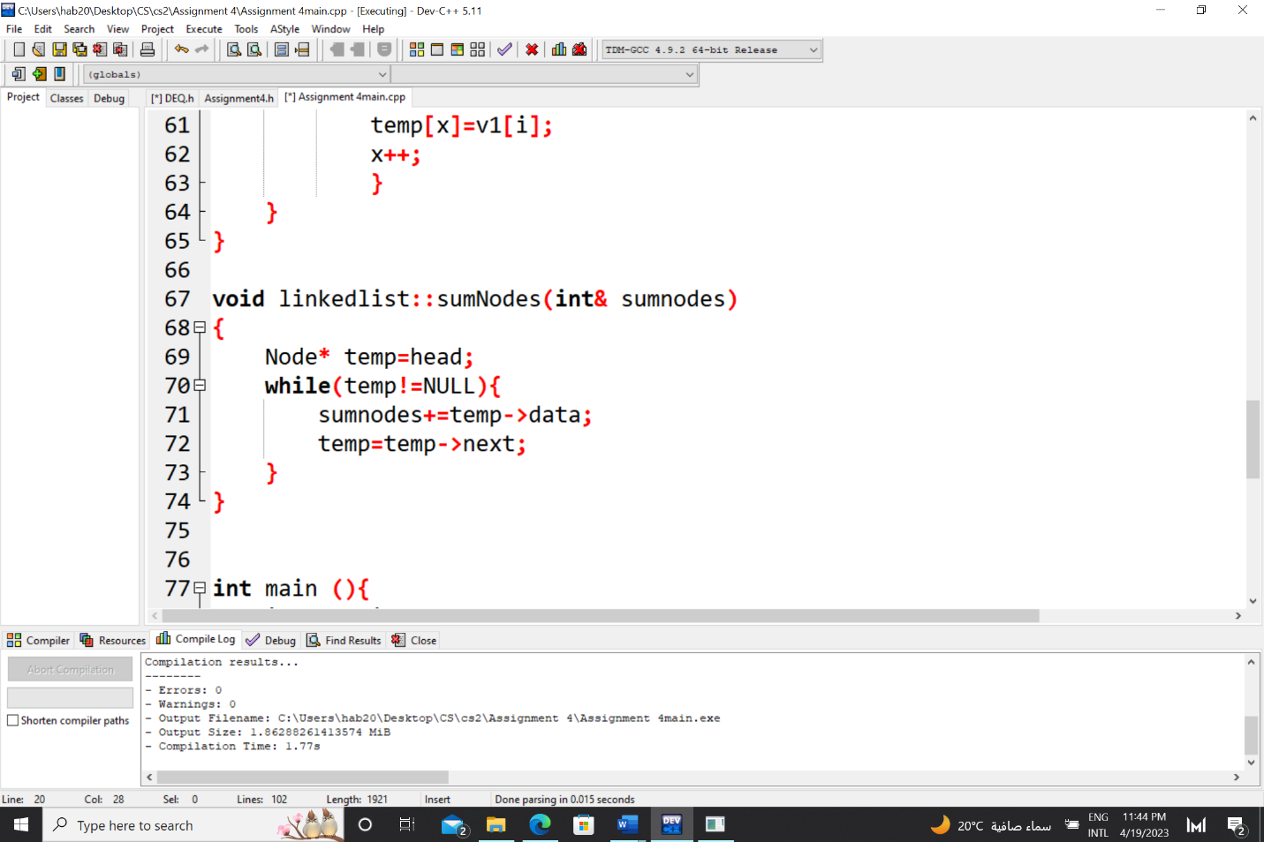

Lastly, the sumNodes function is called to calculate the sum of nodes in the linked list. The linked list is traversed in the while loop and the data of each node is added to the sumnodes variable.

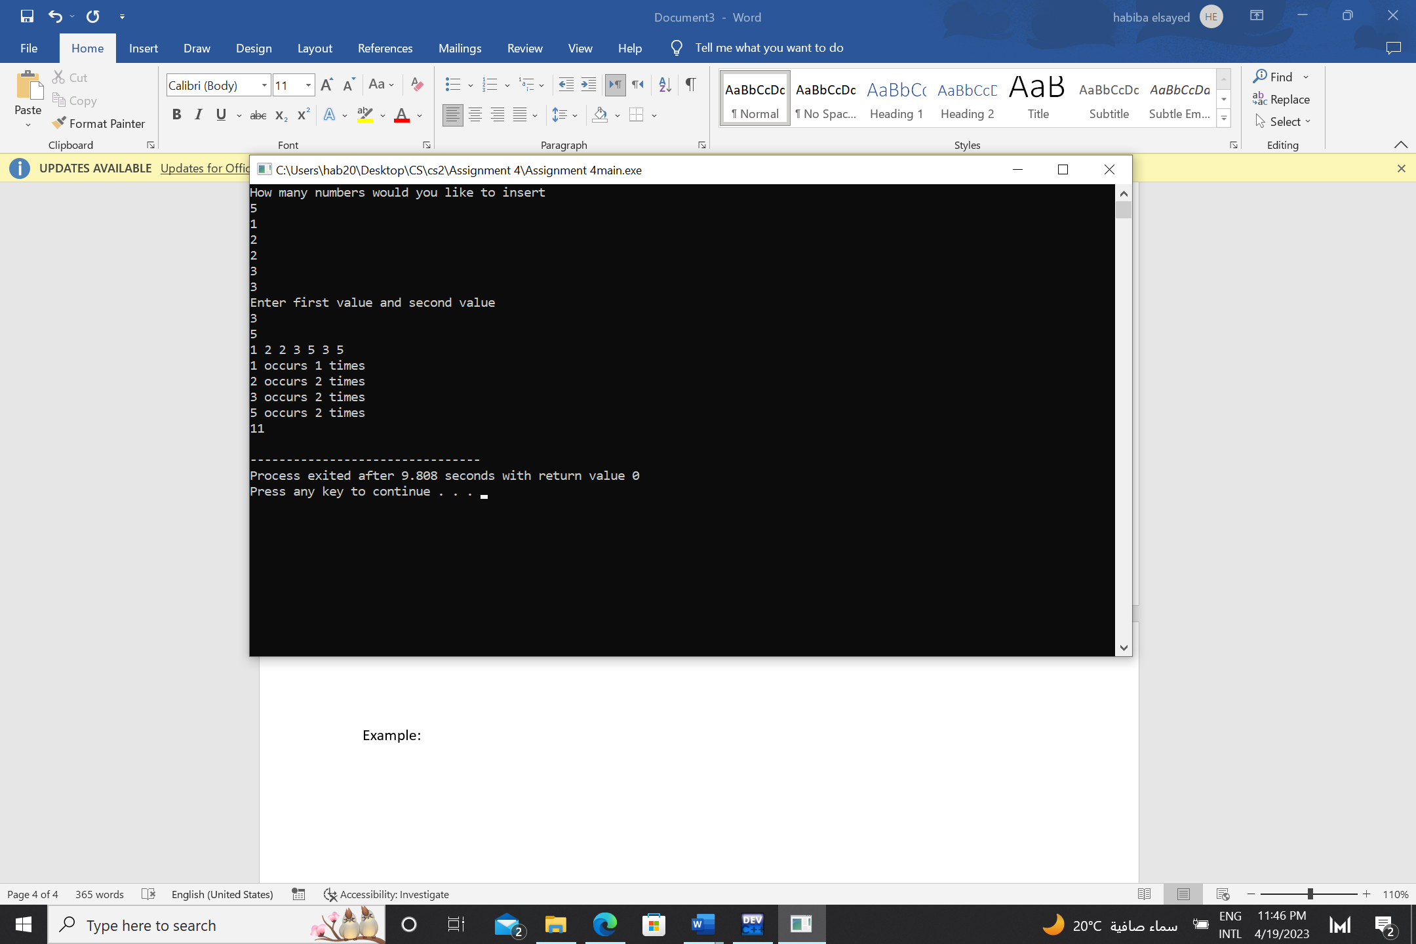Example:

1+2+3+5=11